16 October 2017
AGM and Nominations of Trustees
I am writing to notify you that the Vocational Rehabilitation Association’s Annual General Meeting will take place as follows:
Friday 3 November 2017, at 3.00 pm
Royal College of Occupational Therapists
106-114 Borough High Street
London SE1 1LB

As you may be aware our AGM is traditionally held during our conference but, as we held a joint conference with BABICM and CMSUK, in May 2017, this year’s AGM will take place during a joint study day with the RCOT.
I hope that those members able to attend will also join us for refreshments and networking following the study day.
I strongly encourage you to put the date in your diary, as it is important that we have plenty of members attending the event. The agenda is attached to this letter, and the Chair's report and Treasurer’s report will be reviewed at the meeting.
At the VRA, our Trustees play a key role in supporting the organisation. As part of the AGM we will be holding elections, and I attach a form for application for election as a Trustee of the Vocational Rehabilitation Association 2017-18. Please note that the deadline for receipt of completed nominations is 5.00pm on Friday 27th October. If you would like to discuss the role further, please do let me know.
The process for the elections is as follows:-
1. The membership will be treated as those members registered and duly paid up on Friday 27th October
2. Only members of the VRA are eligible to be nominated to stand for election as Trustees.
3. Each nominee must have a supporter who is also a member of the VRA.
4. Nominations must be submitted by 5.00pm on Friday 27th October, by email, using the attached form.
5. Details of nominees will be circulated to members following this cut-off time.
6. Members will be able to vote in person at the AGM on 3 November 2017, or may submit proxy votes up to 5pm on Friday 27th October. Members will be notified of the process for submitting proxy votes when the nominations are circulated.
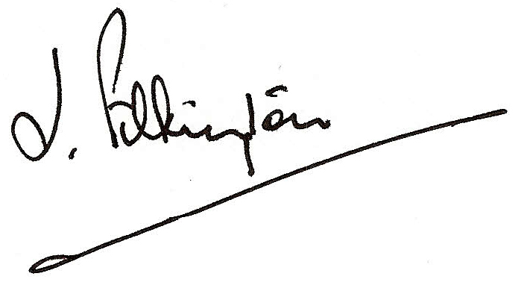
Please note that the arrangements for selecting the Chair, Vice-Chair and Treasurer remain within the Board of Trustees.
Kind regards,

John Pilkington
VRA Chair

VRA AGM 2017
Agenda

Venue: Royal College of Occupational Therapists
106-114 Borough High Street
London SE1 1LB

Date and time: Friday 3 November 2017, at 3.00 pm

Item | Lead
Welcome | John Pilkington, Chair
Minutes of the 2015 Meeting | John Pilkington, Chair
Elections of Trustees | John Pilkington, Chair
Chair’s report | John Pilkington, Chair
Treasurer’s report | Joy Reymond, Treasurer
AOB

