Press Release by Visualise Training and Consultancy – Online version 30/7/18

Eye care and Health Professionals armed with information to improve lives of patients with sight loss

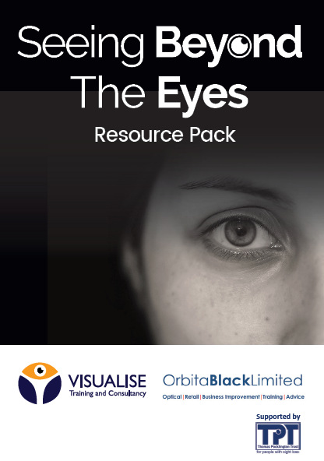
A free resource pack for eyecare and health professionals containing valuable information on sight loss support services, charities, equipment and referral pathways has been produced by Visualise Training and Consultancy with the support of Thomas Pocklington Trust.

The pack complements the ‘Seeing Beyond the Eyes’ CET workshops currently touring the UK which raise awareness of the difficulties faced by patients diagnosed with irreversible sight loss. It contains valuable information on local sight loss charities, Eye Clinic Liaison Officers (ECLO),Vision Rehabilitation Workers, low vision assessment services and Rehabilitation Workers. It also lists national organisations supporting people with sight loss and condition specific charities. Daniel Williams of Visualise said “It is vital patients with sight loss are referred immediately to sight loss services that can enable their independence and help them deal with a difficult time in their life. However Optical professionals can’t refer if they don’t know who they are referring hence why we have created such a resource pack and training roadshow. At the age of 8, I was diagnosed with Retinitis Pigmentosa, a gradual loss of sight, and had consultations with Dispensing Opticians, Optometrists and Ophthalmologists and at no point was I referred to any support services which is why I am so passionate about empowering eye care professionals with the awareness of what is available for people with sight loss to live independent lives”

Links to professional resources are also included such as the Government’s Access to Work grant scheme, an A – Z list of eye conditions and Thomas Pocklington Trust’s guide to designing a home for someone with sight loss.

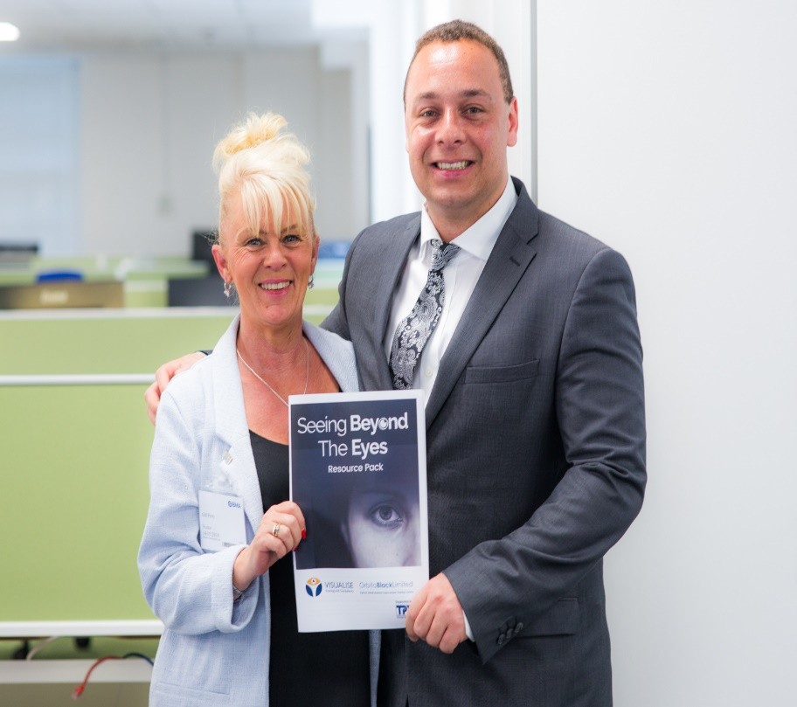
Charles Segal, Dispensing Optician from D and H Hantman Optometrists said “It was one of the best CET courses, I have attended. “I had no idea that there was such a range of services, it made me fully aware of where we can send people and not just refer to the eye hospital, it was a highly informative meeting where the attendees actually met people who are dealing with or have dealt with people with sight loss, it was the first time I have actually met someone who has Retinitis Pigmentosa. It was moving and inspiring to hear how people with low vision get-on with their lives. The course has given me the confidence to help people who enter my practice and give them advice”. “The details of suppliers of low vision aids and daily living solutions are also invaluable for people facing sight loss during their transition to a different way of life”.

The pack can be downloaded free of charge by clicking here

For more information on Visualise Training and Consultancy visit their website

Ends

Notes to Editors:

Visualise Training and Consultancy works nationally and internationally with organisations and businesses to increase awareness of the accessibility challenges faced by employees and or customers with disabilities. Founder, Daniel Williams, who has an eye condition called Retinitis Pigmentosa which causes gradual sight loss, established the business in 2014 to share his knowledge, skills, experience and expertise in this field; he has been expanding and extending this remit ever since.

Contact Daniel Williams daniel@visualisetrainingandconsultancy.co.uk
Tel. 07472305268
http://www.visualisetrainingandconsultancy.com/

Orbita Black is a Management Consultancy specialising in Optical, Retail and Business Improvement Training and Advice and General Optical Council accredited provider of Continuing Education & Training (CET).

Director Peter Black is an experienced director / senior manager / committee member with excellent general management ability and considerable leadership experience. Immediate Past President and Chair of the Board of Directors of the Association of British Dispensing Opticians. Dispensing Standards Manager at Boots Opticians and former Retail Development Director at Conlons.

Contact Peter Black orbitablack@gmail.com Tel. 01695423358

Thomas Pocklington Trust identifies and meets the needs and aspirations of blind and partially sighted people across the UK, by funding and supporting our strategic partners.

Contact Mark Anscombe mark.anscombe@pocklington-trust.org.uk

Tel. 02089 950 880
https://www.pocklington-trust.org.uk

Photos (also attached)

Top: Front cover of resource pack

Bottom: Director Daniel Williams with Executive Assistant Gill Perry of Visualise Training and Consultancy

