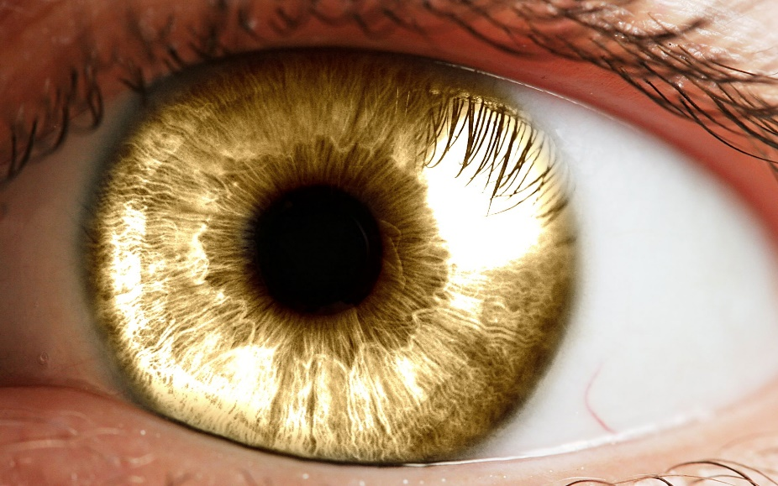

Healthy, Wealthy and Wise Eyes
Healthy eyes – one of the most important appointments you should make is going to see your Optician. One of the important messages employers should be promoting is “Get Your Eyes Checked!”
Society in general are good at attending a GP Practice or Dentist but not so good attending the Opticians?
How do you know your eyes are healthy if you have never been for an eye test? Only your Optician will be able to tell you how healthy your eyes are!
Did you Know Section:
Did you know that 50% of sight loss is avoidable! Yes, we should all know that prevention is better than cure and it is so important that employees attend their Opticians for a sight test not only to check whether they need glasses, but also to check their eyes are healthy too.
Did you know that Opticians are able to pick up minor eye conditions such as dry eye or infections, and a simple eye test can also unearth a number of health conditions that you were not even aware of, such as diabetes, high blood pressure and cardiovascular disease to name but a few?
Wealthy eyes - A regular eye test could prevent loss of income in the future!
Most employers offer free eye test as part of their employee benefits scheme, but is this promoted, are employees reminded this is available to them? Who is monitoring the scheme to establish if employees are accessing this service and who is enforcing it?
Wise employers – Employers are obliged under the Display Screen Equipment (DSE) regulations to provide sight tests for any employee who uses computer screens and displays. If glasses are prescribed to operate the display screen equipment, the employer is then required either to provide glasses for them or contribute towards the cost.

Most employers are aware of this requirement. According to 2008 Health and Safety Executive (HSE) research, just over half (53%) of organisations provided tests. For larger organisations (300+ employees), 100% of those surveyed provided sight tests.

Sight loss does not equal job loss, if someone attends a sight test to be told they have a condition that cannot be corrected, they may fear they will lose their employment. This is not the case, there are many reasonable adjustments that the employer can make to enable that employee with a visual impairment to continue in their role.
Reasonable Adjustment – An employee with a visual impairment should have a work-place assessment to establish their needs and adjustments they may require. This will enable and empower them to continue working just as effectively.
For more information on work-place adjustments please visit
http://www.visualisetrainingandconsultancy.com/consultancy/workplace-assessments/
The 20-20-20 Rule – When looking at a screen for lengthy periods of time ensure you take regular breaks away from the computer screen, the 20-20-20 rule says that every 20 minutes of screen time, you should look away at something at least 20 feet away for at least 20 seconds. These regular screen breaks give your eyes some much-needed rest and help prevent eye strain.
Prevention is better than cure! – To raise awareness of the importance of eye health employers should consider having an Eye Health Care Day and this should be promoted regularly to all colleagues on the run-up and on the day of the event.
A typical Eye Health Day would include –
- The importance of eye health
- Basic sight test
- Raising awareness of visual impairments
- Simulation of visual impairments which will give an eye-opening experience
- A variety of different tasks to complete whilst wearing glasses that simulate various eye conditions.
- Drop-in stand to discuss the importance of eye health
- Advice on Healthy, Wealthy and Wise eyes

For further information please contact:
http://www.visualisetrainingandconsultancy.com/training/visual-impairment-awareness-training/

